Leader Overview
As we look into the experience of Daniel in the lions’ den, we see a man who chose to pray rather than save his own life. He knew that God, the one true God, would listen to his prayers. The testimony of this story is that when we listen and obey God, an entire nation can be impacted. Allow the kids to explore the characteristics of God as the king declares praise to the God Daniel serves.

Bible Lesson
Daniel in the Lions’ Den
Daniel 6:10–27
Faith Fact
God listens when I pray.
Faith Verse
2 Corinthians 5:7 (NLT)
For we live by believing and not by seeing.

Preparing for the Session
Leader Preparation Time: 20–25 Minutes
You Will Need
Large Group
- Bible
- Worship songs (Song suggestions: “All of Me” by Gateway Kids Worship; “This Is Amazing Grace” by Bethel Music Kids; “It’s Your Love” by Gateway Kids Worship)
- For groups not using a phone or tablet only, add:
• Projector or TV
• Laptop
• Rules Video or Slide
• Faith Fact Slide
• Faith Verse Video or Slide
• Bible Lesson Video A
• Bible Lesson Video B
• Beanbag
Small Group
- Beanbag
- Small Group Faith Verse Review
- Card stock
- Scissors
- Cup or basket
- Small Group Activity Page, one per kid
- Ink pad, crayons, or markers

To download session videos, slides, and printables, visit: BibleEngagementProject.com/downloads

Getting Ready
Large Group
- Download videos and slides if needed.
- Select worship song(s) and have them ready to play.
Small Group
- Print the Small Group Faith Verse Review on card stock and cut out each card.
- Print copies of the Small Group Activity Page, one per kid.

First time leading Listen for Kids? Check out the Facilitator Guide.

Large Group
30 Minutes
See what’s needed at the beginning of the session.

Introduction
Hi everyone! We’re so glad you are here! Have you ever been talking and felt like no one is listening? (Group response) I have. Maybe it was your parents not listening, or your teacher, or your friends. How do you feel when people don’t listen? (Allow responses.)
There are other times that people hear you when you don’t even realize it. Have you ever had someone surprise you with a gift or comment on something you like because they had been listening to things you said? (Group response) How does that make you feel?
Today’s Bible story shows us how God listens even when it feels like no one else is listening. The man in our Bible story today was in a situation where the only way his life would be saved was by him trusting that God would save him. It’s a good thing that Daniel had a great relationship with God and prayed to Him every day!
That’s why today our Faith Fact talks about God listening.
• Show the Faith Fact Slide.
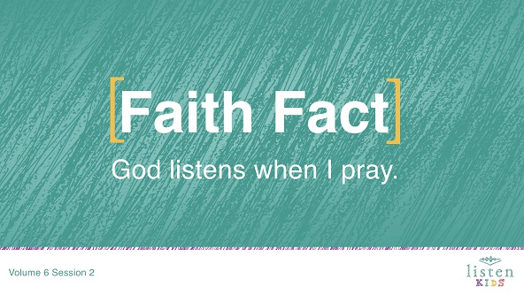
Let’s say it together. God listens when I pray.
To help us remember our Faith Fact, let’s get creative with the way we say the word pray. Sometimes when you pray, you are crying out for help, when you are afraid of the dark, or when you are thanking Him for all He has done. So as we say it again, I want you to say it to sound how you most frequently pray to God. Here we go. God listens when I pray. Great job!
Rules Review (Optional)
Speaking of listening, let’s take time right now to listen to our rules. Let’s watch this video so we know what the rules are.
• Play Rules Video.
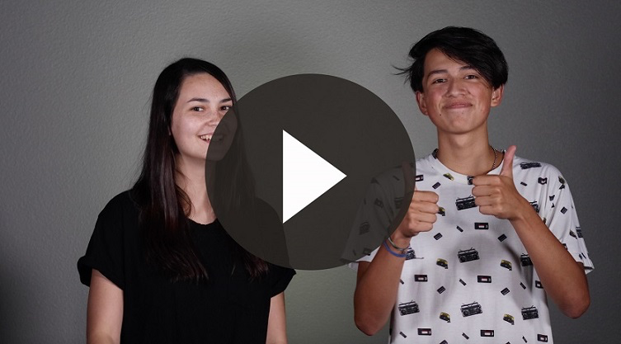

Game
Don’t Wake the Lion!
You Will Need
- Beanbag

No prep needed for this activity.

Have you ever watched a nature documentary where a predator was stalking its prey? In today’s story there is a predator and a prey. The prey in today’s Bible story is a prophet, and the predators who wanted to eat him were lions.
We are going to play Don’t Wake the Lion. In this game, I will select one of you to be the sleeping lion. You will sit away from the group, closing your eyes and turning your back to the other kids. There will be a beanbag behind the sleeping lion. I will pick another volunteer to sneak up on the lion as quietly as possible to retrieve the beanbag and return to your seat. If the sleeping lion hears you approaching or returning to your seat, they can turn around with their eyes closed and point in the direction of the noise. Pointing in the right direction is a win for the lion. Are you ready?
• Play a few rounds depending on how much time you have.
• Change the volunteers for each round. You could let the winning lion pick the new lion.
Great job everyone! Head back to your seats now. Today, we are learning about a time when one man had to stand up to people who wanted to hurt him. We’ll learn that God listens when I pray. Anyone know a story in the Bible about someone who was thrown into a den with a bunch of lions? (Daniel and the lions’ den) All right! Now before we look in the Bible, we will take some time and worship God by singing.

Worship
Did you know that worshipping by singing can be a version of prayer? Sometimes our singing is asking God for something and sometimes we are reminding ourselves that God listens and answers prayers. Let’s sing now.
• Lead the kids in singing one or two praise songs. See suggestions at the beginning of the session.

Bible Lesson
That was such a great time worshipping God! I love worshipping God in singing, and I know He loves to hear our voices. I know that He listens when I worship. In fact, God listens whenever we speak to Him. That’s our Faith Fact today: God listens when I pray. Whenever I say in the Bible story, “God listens,” you should shout out, “when I pray.” Let’s practice that one time.
God listens (pause for kids to shout “when I pray.”). That’s it!
Before we dive into our Bible story, let’s bow our heads and pray together.
Prayer
Dear God, thank You for allowing me to pray and worship You. Thank You for always listening. Amen.

Video Intro
Why don’t we check in with the Challenge Accepted team before we start our Bible story and see what they’re up to?
• Play Bible Lesson Video A.
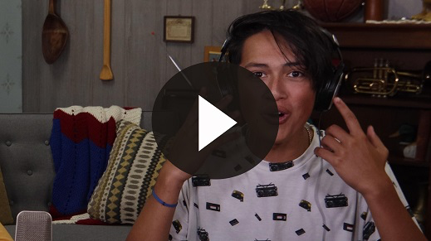
Wow! How do you think you would do with that challenge? (Group response) Time to jump into our Bible story.
Bible Story
Now it is time to open our Bibles to a book that you may have heard about, but may not have ever read before. In the middle of your Bible is a book called Daniel. Let’s find it together. (Open Bible to Daniel.)
Before we read our verses, let me explain what has happened so far. God’s people continued to disobey Him. Some kings led the people to worship false gods, and the nation stopped serving God. God allowed other nations to attack and destroy them.
God listens. (Kids reply, “when I pray.”) God’s people didn’t cry out to Him. Instead they rejected Him, so they faced the consequences of their actions. The Babylonians burned the city of Jerusalem and took many people from their homes. After doing that, the king of Babylon wanted the smartest men to be brought to the palace. In this group of men was a guy named Daniel.
Daniel loved God, and he desired to remain faithful to God even when he was living in the city of Babylon. This was often difficult because the way of life was so different in a foreign country, but God listens. (Kids reply, “when I pray.”) God gave Daniel favor with people and helped him to follow His commands.
The Babylonians were harsh, and their king did not obey God. One time King Nebuchadnezzar sent guards to kill Daniel because the king had a bad dream, and no one could tell him what the dream was. But, Daniel and some of his friends prayed to God for help. God listens. (Kids reply, “when I pray.”) God told Daniel what the dream was and what it meant. Then Daniel told the dream and its meaning to the king who spared Daniel.
Later, that same king threatened to throw people in a huge fire if they refused to bow down and worship his golden statue, but God listens. (Kids reply, “when I pray”) God protected Daniel’s friends when they were thrown into the fire.
The Babylonians refused to obey God, and they were defeated by the Medes and Persians. Darius the Mede becomes the new king. He promoted three men to be his supervisors, one of them Daniel. In fact, Daniel did such a great job that Darius considered putting him in charge of the whole kingdom. How do you think the other supervisors felt? (Group response)
All of the other leaders were jealous of Daniel because he had favor with the king. So, they tried to find fault with the way Daniel did his work. Do you think they found anything wrong with Daniel? (Group response)
• Read or have a kid read Daniel 6:4–5.
The Bible says they couldn’t find anything to criticize Daniel for. So they created a plan to destroy Daniel with a law that would force Daniel to choose between his loyalty to God or to the king.
All of the leaders went to the king in agreement to propose this new law. Let’s read what they said to him in Daniel 6:7.
• Read or have a kid read Daniel 6:7.
Okay, so help me understand. What does everyone have to do for the next thirty days? What happens if you pray to someone else? So what happens if you pray to a statue of a chicken? What happens if you pray to the stars and moon? What happens if you pray to the one true God, who created everything and listens to our prayers? (Group response. You would be thrown into a den of lions.)
How do you think it made the king feel that people would only be able to pray to him? Maybe he was excited about the idea because it would make him feel more powerful and more important. The king signed the law, which meant that it could not be reversed, even if the king wanted to reverse it.
Daniel had to make a choice—pray to a person with the title of king or pray to God, the King of all kings. Who do you think Daniel chose? (Group response) Let’s read what happened in Daniel 6:10.
• Read or have a kid read Daniel 6:10.
Daniel went home to pray. He regularly prayed to God three times a day, and he wasn’t going to stop because of the new law. Why? Because God listens. (Kids reply, “when I pray.”)
Daniel was going to be in a lot of trouble because he had broken the law. But, he was faithful to God. He knew that God had kept him safe all the years he had been living in Babylon. God listens. (Kids reply, “when I pray.”)
The people who wanted to get Daniel in trouble went straight to the king and told him what Daniel had done. They had Daniel brought to be thrown into the den of lions.
The king was upset because he really liked Daniel and didn’t want to see him die. Do you think King Darius wished he had never signed the law? (Group response)
Daniel didn’t need the king’s help. Daniel had already prayed to God. Daniel knew what we know—God listens. (Kids reply, “when I pray.”) Let’s read what happens next in Daniel 6:16.
• Read or have a kid read Daniel 6:16
Even King Darius knew that only God would be able to help Daniel. He was thrown into the den, and a stone was placed over the opening, sealing him inside. No one would be able to save Daniel. The king went back to his palace and was up all night upset about what had happened.
Very early the next morning, Darius hurried to the lions’ den. These lions probably hadn’t eaten in days, and there was no way that Daniel would have lived unless God saved him. King Darius had the stone removed and yelled down into the den.
• Read or have a kid read Daniel 6:20
It was quiet. The king’s voice echoed inside the den. He was hoping for any sound. Suddenly, Daniel spoke.
• Read or have a kid read Daniel 6:21–22.
The king was so excited. He had Daniel pulled out of the den, and there wasn’t a single scratch on him. God had saved Daniel because God listens. (Kids reply, “when I pray.”) Then, the king had the men who had accused Daniel thrown into the lions’ den. What do you think happened? (Group response) You’re right. Even before the men reached the floor of the den, the lions killed them.
The same king who had said that people had to pray to him made a new law that people throughout his kingdom should fear and reverence Daniel’s God. Let’s read what he said in Daniel 6:26–27.
• Read or have a kid read Daniel 6:26–27.
Teaching Time
What was special about Daniel? He prayed and believed that God would always take care of him. He knew that no matter what challenges came his way he could always pray to God. More than anything, he knew God listens. (Kids reply, “when I pray.”)
God didn’t listen just to Daniel; He listens to you and me, too. We can be confident that God cares about our lives, even the smallest details, and that He wants us to pray to Him. Praying is simply talking to God. God wants to hear all about our lives, and we can talk to Him like our closest friend.
When it comes to prayer, sometimes it’s easy to be embarrassed because we don’t want to say the wrong thing. Here’s some great news! God isn’t concerned about us saying perfect prayers. He wants us to speak to Him about what we’re feeling in our hearts. He wants us to share our secrets and the things that we might not want to share with anyone else. When we do that, we can be confident that God listens when I pray.
Faith Verse
When we pray, it takes faith to believe that God listens when I pray. Today’s Faith Verse from the Bible reminds us about the importance of believing. We can’t see God, but we know that He is always there and listens to our prayers. Let’s do the actions together as we say the verse.
• Play Faith Verse Video.
2 Corinthians 5:7 (NLT)
For we live by believing and not by seeing.
I know that we can’t always hear God. It takes faith to believe that He hears and listens to us. When we see Him answer our prayers, it helps our faith to grow more and more.

Prayer and Response
Consider playing a worship song softly in the background while kids pray.
Today as we pray, there are so many things we could ask God for, and God listens to all of those things. Let’s take time to focus on just one prayer today, just one thing. We are going to ask God to show us the one thing we should pray about today, knowing that God listens when I pray.
We are going to be like Daniel and find a spot in the room to bow down and pray. Remember, Daniel prayed three times each day. We are going to pray right now, but remember to keep praying. As we pray, I want you to ask God, “What is the one thing I should pray for today?”
If you’ve given your heart to God, listen to that little prompting of God’s Spirit inside of you and then pray about that because we know that God listens when I pray.
• If there are kids in the group who haven’t yet given their heart to God, take time to pray with each one individually or have designated leaders who can do that.
• Give kids time to pray. Then introduce the worship song. This could play in the background while kids pray or could be a worship song to sing together.
Worship Song
Play a worship song.
Video Wrap-Up
We are going to break into our small group activities, but first let’s see how the Challenge Accepted team did with their challenge.
• Play Bible Lesson Video B.
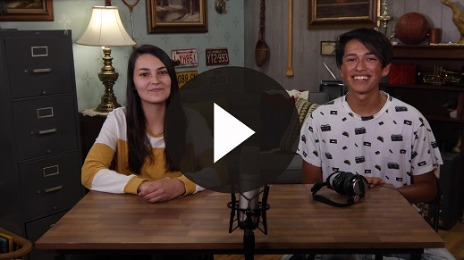
Let’s all accept the challenge that Dash gave us to spend at least five minutes every day talking to God. Let’s choose to pray, knowing that God listens to each and every one of us just like He listened to Daniel. Let’s remember our Faith Fact.
• Show the Faith Fact Slide.
Say it with me again so that we never forget this truth. God listens when I pray. That was a great time learning about God together.
• Dismiss kids to Small Group time or to go home if your group time ends here.

Small Group
30 Minutes
This section can be done in conjunction with the large group, or on its own if you do small groups with your kids. During Small Group time, the goal is to connect the kids with the Word of God and to each other. All activities are led by the small group leader.

Group Connection
Beanbag Pass
You Will Need
- Beanbag

No prep needed for this activity.

We are going to sit in a circle and toss a beanbag to one another. Before you throw the beanbag, you have to say the name of the person you are throwing it to and say, “God listens.” Before the other person catches it, he or she has to say, “when I pray.” If you take too long to say the rest of the Faith Fact, then you are out. I will start the game.
• As kids get used to this game, make it more challenging by adding in more actions. For example, kids could have to clap their hands twice before they catch the beanbag.
• Play a few rounds. You could also modify the game by getting kids to say the Faith Verse in a three-kid round. (Example: Kid 1 says, “2 Corinthians 5:7.” Kid 2 says, “For we live by believing.” Kid 3 says, “and not by seeing.”)

Bible Lesson Recap
You Will Need
- Bible, one per kid

No prep needed for this activity.
Bible Story Review: Daniel 6:10–27
Let’s review our Bible story by reading what the Bible says about the Faith Fact: God listens when I pray. Turn to the Book of Daniel and let’s read this passage.
• Divide the Bible reading into smaller chunks for kids to read aloud.
You kids did a great job. It’s great to know a Bible story, but there is always something new to learn every time you hear it.
Faith Fact
Daniel couldn’t see God, but he believed that God would listen to his prayers. As I read the Bible, it reminds me of our Faith Fact.
• Show the Faith Fact Slide.
Say it with me: God listens when I pray.

Group Discussion
Feel free to use all or just a few questions as a jumping-off place for good discussion. Questions marked with * are designed for more conversation. Adjust the questions based on the age or maturity of your group. Typically, older kids will be able to dive a little deeper than younger ones.
Questions
What were the names of the kings in today’s story?
Why do you think the other leaders were trying to kill Daniel? How would you feel if everyone around you was trying to hurt or make you look bad?
Today, we learned that God listens when I pray. How did we see that in the story? If God listened to Daniel, will He listen to us?
What was the law that was made and what were the consequences? Why do you think the king would have signed the law?
How do you think Daniel felt the first time he kneeled to pray, knowing that people were watching him? How would you have felt?
The Bible shows us how the king responded through this entire time. How did the king respond before Daniel was brought to him? How did the king respond when Daniel was thrown into the den? How did the king respond the next morning? How did the king respond when it came to worshipping God?
Imagine that you are Daniel. What were you thinking during this experience? When you were brought before the king? When you were thrown into the lions’ den? With the lions? When God kept the lions from hurting you? When the king came the next morning?
Why do you think God didn’t rescue Daniel before he was thrown in the lions’ den?
* We know that God listens when I pray, but He doesn’t always answer us at the time we want Him to. Is there a time that God answered your prayer, but it didn’t happen exactly when you thought it was going to?
Can you think of any other times in the Bible when God listened and answered someone’s prayer?

Application and Response
We may never be in a situation where we will have to choose between praying or being eaten by lions. But, there will be times we have to choose between obeying or not obeying God. There will be times where we are in a situation from which only God can rescue us, and we need His help. In these times I can remember what Daniel went through, and I know that God listens when I pray.
This wasn’t the first time Daniel had trusted God. If you read earlier in the Book of Daniel, you will see that Daniel trusted God about eating certain foods and interpreting dreams. Because God had answered his prayers before, Daniel knew that God would listen to his prayers this time.
Make It a Habit
Select a simple visual reminder of the session’s Faith Fact.
We need to remember that God listens when I pray. One way we can do that is to remind ourselves of times when God listened and answered our prayers. Think back to a prayer that God has answered for you. Maybe it was as simple as praying to feel better or for fear to go away at night. Maybe it was something bigger than that.
When I pray for something, I like to remind myself and God about the last time He answered my prayer. Then when I pray, I can be confident that God listens when I pray. Let’s think of something that God did for us and make a quick action to represent it. (Group response) Great! Now, let’s all do our actions at the same time to help us remember what God has done for us.
Prayer
Let’s pray and thank God for listening to us.
Father God, thank You for listening to each of us when we pray. Your Word says that You listen and answer our prayers. We are so thankful for all You have done and continue to do in our lives. Amen.

Faith Verse Review
You Will Need
- Small Group Faith Verse Review
- Card stock
- Scissors
- Cup or basket
Getting Ready
- Print the Small Group Faith Verse Review on card stock and cut out each card
- Place the cards in the cup or basket.

Our Faith Verse is 2 Corinthians 5:7. It helps us understand what faith is, especially as it relates to prayer. Let’s say the Faith Verse and do the actions together.
• Show the Faith Verse Slide.
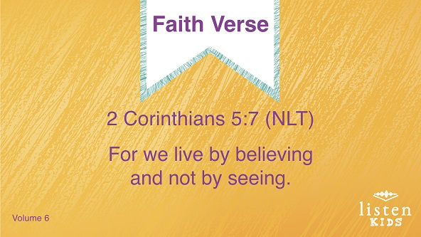
2 Corinthians 5:7 (NLT)
For we live by believing and not by seeing.
Faith Verse Fun
Hear a Hole
You guys sound great! Just as God listens when I pray, today we are going to see how well you listen to each other. We are going to take turns reading the Faith Verse from cards. There are words missing from the verse that you won’t say, leaving a hole in the Faith Verse. The rest of us have to guess which word will fill the hole you heard. Everyone can have a turn to read. The rest of us will listen close enough to hear what’s missed. Let’s try it.
• Have each kid take a card from the cup to read.
• If you have a large group, collect the cards, shuffle them, and put them back into the cup so each kid has read a card.
Now that everyone has read a card, I think you kids listened well. Even though you couldn’t see the verse in front of you, you were able to know what the right thing to say was because you’ve learned 2 Corinthians 5:7. Great job!

Creative Activity
I’m Not Lion …
You Will Need
- Small Group Activity Page, one per kid
- Ink pad, crayons, or markers
Getting Ready
- Print copies of the Small Group Activity Page, one per kid.

Today, we heard that God listens when I pray. We read that Daniel was saved from the lions’ den because God listened and heard his prayer. On today’s Activity Page, there’s a picture of a lion’s face and the words, “I’m not LION … God listens when I pray.” Using the ink pad, make fingerprints to give the lion a mane and color it in as desired.
Prayer
Thank You, God, for always listening when I pray. I know that I can trust You no matter what and that You always answer my prayers at just the right time. Help me to listen to You more and more each day. Amen.

Faith Fact Recap
• Display the Faith Fact Slide as parents are coming into the room.
• Maximize the time you have with your kids, so that parents see what their kids have learned. Have the kids repeat the Faith Fact, and then dismiss them to their parents.
We heard a lot today, but one of the most important things we want to remember is our Faith Fact.
• Show the Faith Fact Slide.
Say it with me: God listens when I pray.

Dismissal
• Send home the Small Group Activity Page with each kid.
• Remind parents that there are Family Devotions available on the app to do with their kid.
• Tell everyone the date and time for the next session.

